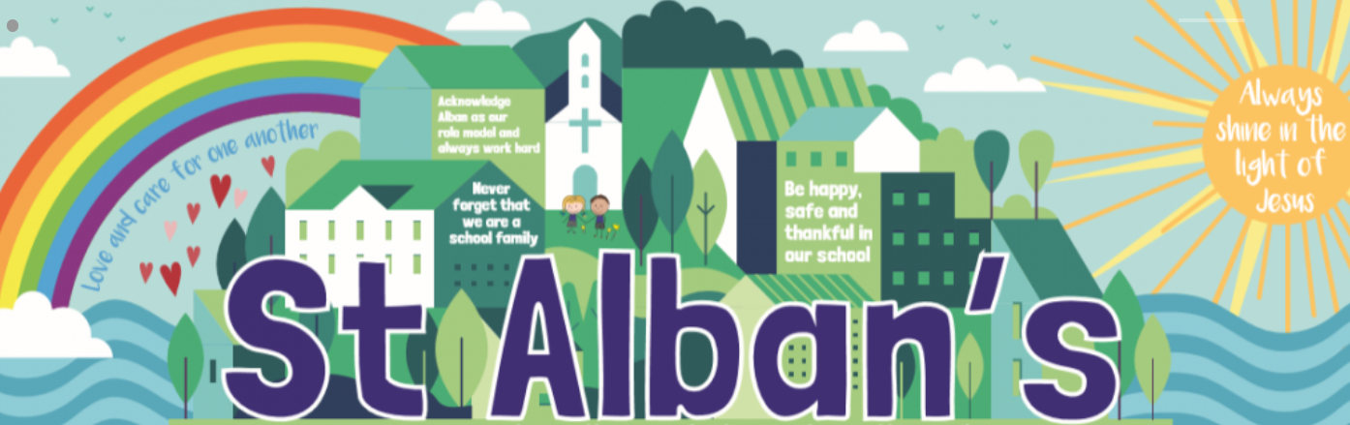

St Alban’s Catholic Voluntary Academy
Upper Key Stage 2 Curriculum Map
Cycle A

Main Enquiry Question – Why should the rainforests matter to all of us?
Focus Text – The Explorer by Katherine Rundell
Term | Humanities | Science Driver | RE | Music | Art/DT | PE | Computing | PSHE
Advent  1 | Geography - Rainforests |  | Ourselves  Vocation and Commitment  Hope | Jembe | Skills – Creating texture using a variety of sketching techniques and shading. | Invasion games | Coding | Being healthy
Advent  2 |  | Biology –  Living Things and their Habitats  Classification |  | Jembe | A study of Henri Rousseau  Repeated prints | Invasion games | Online Safety | Bullying matters
Main Enquiry Question – How could Hitler have convinced a nation like Germany to follow him to war?
UKS2 Lent Term – Focus Text Goodnight Mr Tom by Michelle Magorian & Letters from the Lighthouse by Emma Carroll
Lent  1 | History - World War II | Physics –  Forces | Sources  Memorial Sacrifice  Death and New Life | Jembe | Skills - Perspective | Fitness, dance, gymnastics | Spreadsheets | Relationships
Lent  2 |  | Physics –  Light |  | Samba | The work of War Artists from WWI and II including Paul Nash, L.S Lowry | Fitness, dance, gymnastics | Databases | Exploring emotions
Main Enquiry Question - From the end of the Roman occupation to 1066: how did Britain change?
Focus Text Beowulf by Michael Morpurgo & Shakespeare’s Macbeth
Pentecost  1 | History - End of Roman Empire to 1066 | Chemistry – Reversible and irreversible changes | Transformation  Healing  Stewardship | Samba | Anglo Saxon Arts and crafts. | Athletics | Game Creator | Difference and Diversity
Pentecost  2 | Geography – Mapping Skills |  |  | Samba | Recreation of an Anglo-Saxon settlement | Athletics | 3-D Modelling and Concept Maps | Money Matters
‘Learning together, side by side with God’

