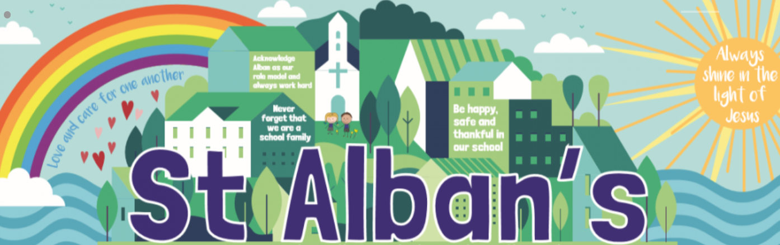
St Alban’s Catholic Voluntary Academy
Lower Key Stage 2 Curriculum Map
Cycle A

LKS2 Advent Term
Term | Art/DT | Science | Computing | Music | Geography | History | PE | RE | PSHE
Advent 1 | Design and make a pyramid. |  | Coding | Y3/4 Singing lessons – Singing partnership. | Locational Knowledge | Ancient Egypt  How could you reach the afterlife? | Invasion Games | Homes  Called | Exploring Emotions
Advent 2 | Design and make a meal  Design and make a game. | Physics  Rocks and Soils  What do rocks tell us about the way the Earth was formed? | Online Safety  Spreadsheets |  |  |  | Gym & Dance | Called  Visitors  Judaism (1 week) | Relationships
LKS2 Lent Term
Lent 1 | Design and create a rock sculpture. | Physics  Electricity  How would you cope for a day without electricity? | Touch typing | Y4 Singing lessons – Singing Partnership |  | Ancient Greece  Why were the Ancient Greeks ruled by their Gods? | Fitness  Badminton | Community  Listening and Sharing | Bullying Matters
Lent 2 | Design and sculpt a clay pot. |  | Email  (including email safety) |  | Comparing Derby and Modern Greece.  Why do so many people choose to go to the Mediterranean for their holiday? |  | Basketball | Listening and Sharing  Self-discipline | Money Matters
LKS2 Pentecost Term
Pentecost 1 | Create landscape paintings using watercolour. | Chemistry  States of Matter  How would we survive without water? | Branching database | Y3 Singing – Singing Partnership | Rivers  Where would you choose to build a city? |  | Athletics | Energy  Building Bridges | Difference and Diversity
Pentecost 2 | Sketching based on human observations. | Biology  Animals, including humans.  How can Usain Bolt run so fast? | Simulations  Graphing |  |  |  | Striking & Fielding Games | Building Bridges  Special Places | Being Healthy
‘Learning together, side by side with God’

