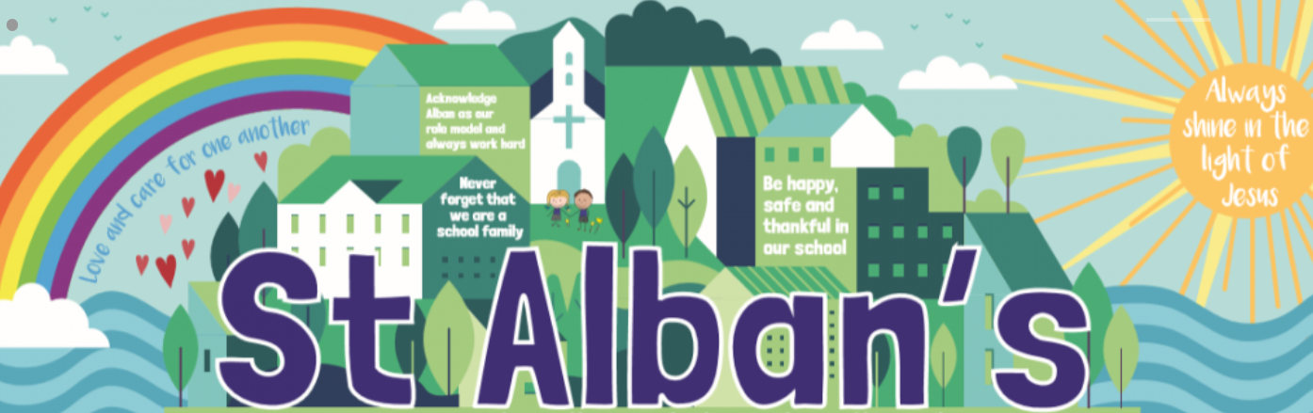
St Alban’s Catholic Voluntary Academy
Key Stage One Curriculum Map
Cycle A

KS1 Advent Term
Term | Art/DT | Science | Computing | Music | Geography | History | PE | RE | PSHE
Advent 1 | William Morris, repeating patterns  Sketching | Physics  (Seasonal changes)  Why are there so many leaves on the floor? | Online safety and exploring Purple Mash  Effective searching | Ourselves - exploring sounds (1)  Seasons – pitch (2) | Name a locate the 4 countries of the UK |  | Invasion games | Families  Signs & symbols | Being healthy
Advent 2 | Make a toy with a moving part | - | Lego Builders  Technology outside school | Nativity/Christmas  The Beatles |  | Toy Story  Are ipads more fun than a yoyo? | Invasion games | Signs & symbols Waiting | Bullying matters
KS1 Lent Term
Lent 1 | Colour mixing  Make a dinosaur’s home | Biology  (Animals)  Would a dinosaur make a good pet? | Grouping and sorting | Weather – exploring sounds (1)  Mozart |  |  | Fitness, dance, gymnastics | Books  Meals | Relationships
Lent 2 | Hold and cold pictures  chalks |  | Creating pictures  Spreadsheets | Number - beat (2) | Polar explorers  Do penguins live by the equator? | Race to the pole Captain Scott | Fitness, dance, gymnastics | Meals  Opportunities | Exploring emotions
KS1 Pentecost Term
Pentecost 1 | Design a bird table  Plant sketching | Biology (plants)  Which birds would you find in the park? | Coding | Storytime – exploring sounds (1)  Queen |  |  | Athletics | Holidays/ holy days  Rules | Difference and Diversity
Pentecost 2 | Make a traditional board game |  | Coding | Water – pitch (2) | Derby Detectives  Local area study | Florence Nightingale | Athletics | Rules  Neighbours | Being responsible
‘Learning together, side by side with God’

