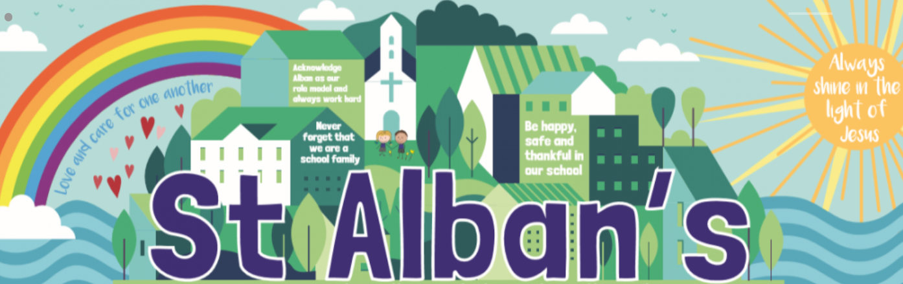

St Alban’s Catholic Voluntary Academy
VGP long term plan 2020 Cycle A
Year 3 and 4

 | First few weeks | Autumn 1 | Autumn 2 | Spring 1 | Spring 2 | Summer 1 | Summer 2
Purposes | Basic skills refocus | (E) Poetry – For display  (E) Setting description  (I) An information text on the Nile.  (E) Story writing (including comparative judgement piece Y3) | (E) Story writing continued based on an innovation of Egyptian Cinderella.  (I) Explanation text on Mummification  (E) Christmas Poetry | (E) Character description  (E) Rewriting a Myth in the 1st person. | (E) Writing a description in the present tense.  (P) Why would you make a good Greek warrior? | (I)Information text on the Water Cycle  (D) Should we build a new park on a reservation site? | (E) The River – by Valerie Bloom (off by heart)  (I)Information text about a river
Topic Driver | - | Ancient Egypt | Ancient Egypt | Ancient Greece | Ancient Greece | Rivers | Rivers
Texts | After a Fall | Non-Fiction texts about the Nile.  Egyptian Cinderella. | Egyptian Cinderella  Non-fiction explanation texts. | Greek Myths – Marcia Williams | Greek Myths – Marcia Williams | The Wind in the Willows | Non-fiction texts about Rivers
NC Objectives | Writing simple sentences and caption, letter formation  Phonics  Intial teacher assessments  Mental health and routines at school | Sentences with different forms: statement, question, exclamation, command.  Paragraphs  Revise: noun, subject, verb, object to form a simple sentence with correct punctuation.  expanded noun phrases to describe and specify  Learning how to use both familiar and new punctuation correctly, including full stops, capital letters, exclamation marks, and question marks.  Co-ordination (using or, and, & but)  Subordination (using when and because.) | Grouping related ideas in paragraphs  Fronted adverbials (using commas correctly.)  the present and past tenses correctly and consistently including the progressive form  choosing nouns or pronouns appropriately for clarity and cohesion and to avoid repetition (Y3 &4)  using and punctuating direct speech (including punctuation within and surrounding inverted commas)  apostrophes for omission & singular possession  commas for lists | some features of written Standard English  Suffixes to form new words (-ly,) adverbs  the present and past tenses correctly and consistently including the progressive form  expanded noun phrases to describe and specify  commas in lists  Adjectives, adverb, Pronoun/possessive pronoun  Fronted adverbials (using commas correctly.) | Standard English verb inflections (I did vs I done)  Extending the range of sentences with more than one clause by using a wider range of conjunctions, including when, if, because, although (Y3 & 4)  extended noun phrases, including with prepositions  Fronted adverbials (using commas correctly.)  Co-ordination (using or, but ,)  Subordination (using if, since, although, as, whilst, when, before, after, until, because. | expanded noun phrases to describe and specify  proposing changes to grammar and vocabulary to improve consistency, including the accurate use of pronouns in sentences  proofread for spelling and punctuation errors  extended noun phrases, including with prepositions  Fronted adverbials (using commas correctly.)  Extending the range of sentences with more than one clause by using a wider range of conjunctions, including when, if, because, although (Y3 & 4) | Consolidation and specific class gaps.  proofread for spelling and punctuation errors

